PH126: Exercises 00 (normal only, for fast-track exercises see fast-track handout 01)
From Barwise & Etchemendy, Language, Proof and Logic (those marked * are optional).

Be sure to read the corresponding parts of the textbook before attempting to complete the exercises. (I.e. read §§1.1–3 before attempting part B, read §1.4 before attempting C, and read §2.1 before attempting D.)
A. complete 'you try it' on pp. 8-10
B. 1.1–1.5 (*1.6) on pp. 25-6
C. 1.8–1.10
D. 2.3, 2.4 (arguments and validity)
E. State the textbook definition and page number for each of the following:
- argument [p. 41] | - name
- premise | - object
- conclusion | - predicate
- logically valid argument | - property  - truth value
 | - atomic sentence
*F. (optional) Disambiguate the following by giving alternative readings.
Example:
  - Pierre is a foreign coin collector.
– Pierre is foreign and he collects coins.
– Pierre collects foreign coins.
  - Tom is kind and brave or foolish
  - Kids make nutritious snacks.
  - I want to marry a Norwegian.
  - We are now serving live lobsters.
  - The door is alarmed.
  - This is a hospital where doctors are trained.
  - Ormus said that Vina was happy then.
  - No one hates a man after he shoots him.
  - A woman and a girl each had a hat and the woman gave hers to the girl.
  - One can’t remove the rods too quickly.
  - Ayesha clumsily stamped on a snail.
(Some examples are from http://www.vuse.vanderbilt.edu/~jgray/funny.html)

Submit 1.1–1.5 & 1.9 using grade grinder. Submit 1.8, 1.10, E & F by email or on paper directly to your seminar group leader.

When are they due?
2pm on the day before the seminar (unless otherwise instructed). This includes work submitted with Grade Grinder.

How to submit?
You need to submit some of these exercises to your seminar group leader.* You can put them in their pigeon hole in the Philosophy Department. Or you can email them to your seminar group leader.

Using Grade Grinder
When using Grade Grinder, be sure to enter your seminar leader’s* name and email address in the ‘instructor’s name’ and ‘instructor’s email address’ sections. E.g.:

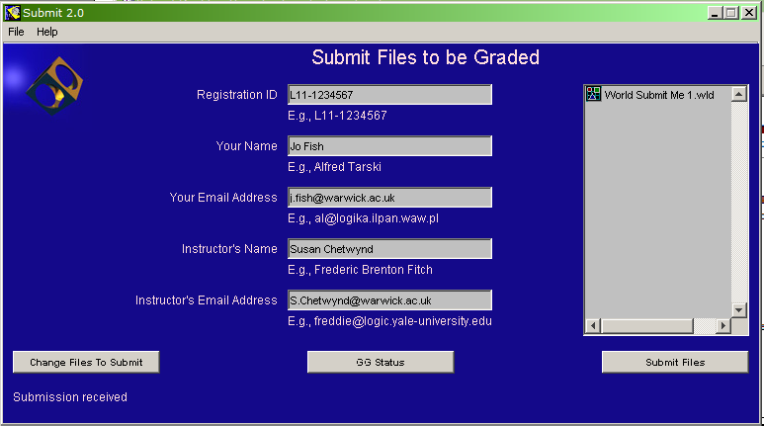

Students should submit work electronically using Grade Grinder. However, individuals may exceptionally submit any or all exercises on paper if they have reason to do so.
*Not sure who your seminar group leader is? First sign up for a seminar group (http://reporttool.warwick.ac.uk/philosophy), then click on the name of your seminar group and select the ‘details’ tab.

What if I can’t do the exercises?
Ask a friend. Or submit your best attempt. Seminars are compulsory but students may not attend a seminar unless they have either submitted attempts at the exercises emailed their seminar group leader for special permission (e.g. in case of illness).
Work submitted late may not be marked.

